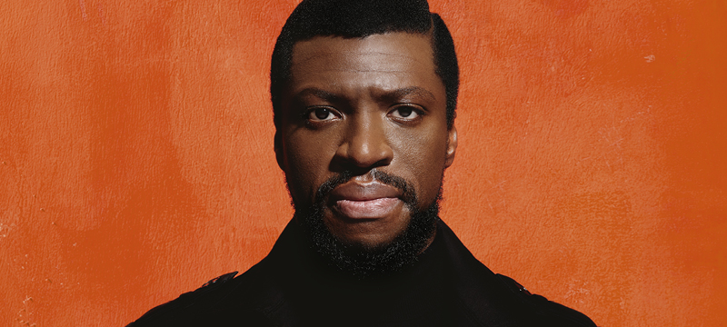
Pre-Show Information
Young Vic presents
In proud partnership with the Mandela family. Co-produced with Nandi Mandela, Luvuyo Madasa, Shaun Hurwitz, Ronen Zekry, Greg Dean Borowsky, Shaun Borowsky and Brian & Dayna Lee
Book by Laiona Michelle
Music and Lyrics by Greg Dean Borowsky and Shaun Borowsky
Directed by Schele Williams

This document contains detailed information about the show in order to describe what you should expect when attending.
This includes information about the content warnings, plot, the space, lighting and sound, audience participation, and further access information.
All of the information in this document was correct at the time of publishing. More information will be available closer to the time of performance.
Please note that by discussing the content of the show, the below information will contain key plot points and descriptions of what happens in the performance.
If you would like to receive elements of this information but avoid these spoilers, please do not read the sections at the end of this document ‘Show Information’ and ‘Show Synopsis’.
If you have any questions, please do not hesitate to contact our Box Office team:
E-mail: boxoffice@youngvic.org
Phone number: 020 7922 2922

The Auditorium
Mandela
This show will take place in our main auditorium, which is the larger of our three performance spaces.
For this performance, the space will be in a ‘end on’ arrangement, meaning the seats are arranged on three sides of the stage (see below). The current capacity is 426.
Access to the main auditorium is via the upstairs (rows K – Q) and downstairs (rows A – J) via the main doors. Our ushers are on hand to help you, they wear red t-shirts and jumpers with our logo.
Please arrive at the Young Vic with your ticket ready on your phone or have it printed before you enter or you can collect from box office.

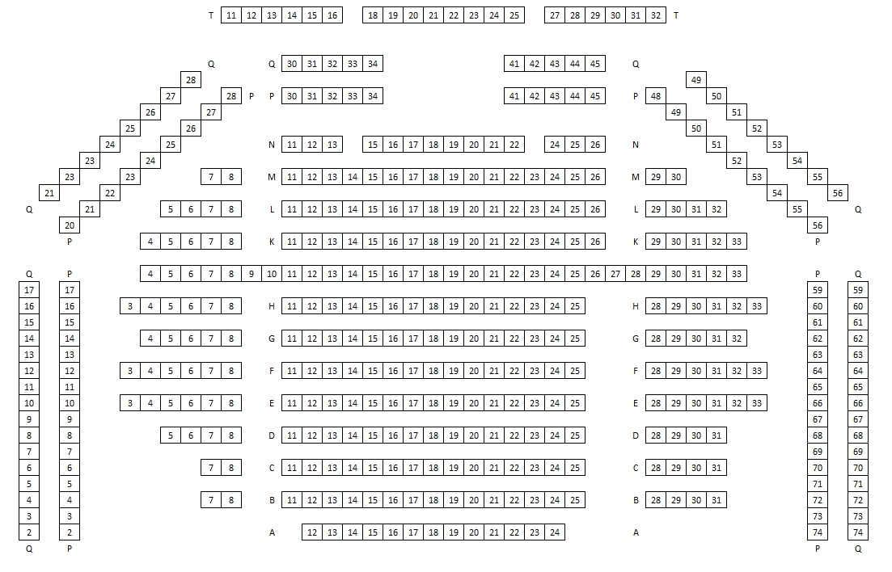

Facilities:
There are toilets located on the ground and first floor at the Young Vic, via The Cut Bar. We have gender-neutral and disabled/baby changing toilets. Sanitary bins are available in all. All indoor venues will also be accessible with lifts & ramps and toilet provided.
Assistance Dogs:
Assistance dogs are always welcome at the Young Vic, if you are planning a visit please let us know in advance which performance you will be attending by calling our box office on 020 7922 2922 or e-mailing boxoffice@youngvic.org and we will be happy to look after your dog during the show.
Access for all:
For full information about or access measures, please visit our Access for all page, on our website here: www.youngvic.org/visit-us/access-for-all
Show Information:
Content Warnings:
The show contains themes of racism and violence and there are displays of physical aggression – particularly the shooting of Black and Global Majority people. There is use of prop guns and loud gunshot and bomb blast sound effects. The show also contains scenes of a massacre and references the killing of young people and intense emotional and hallucinatory states.
Sound:
- Loud gunshots
- Bomb blast sound effects
Lighting:
- Flashing lights
- 20 seconds of total darkness
Stage:
- Prop rifle guns
- Fog
- Haze
- Lit cigarettes
Show Synopsis:
Act I

Act I (“MANDELA SONG”) We are met with the melodic hums of anti-apartheid supporters at an anti-apartheid rally as the Prime Minister delivers a speech to the nation. Mandela addresses the crowd of supporters and delivers a speech. Reflecting on Mandela’s speech, Mandela and his comrades begin to lead the march, a volley of gun shots cuts the applause as a massacre unfolds (“SIYABATHANDAZELA”).
At the Mandela home, Winnie lays her crying toddler down as she sings a lullaby (“PIECE OF US”).
(“FIRE WITH FIRE”) The Prime Minister addresses the nation and begins by commending the police for maintaining order at the anti-apartheid rally as Mandela, Oliver, Walter and Kathy discover the carnage from the massacre. As the address continues, anti-apartheid supporters gather in Joe’s hideout to discuss details of their operation.
Mandela sings as he looks at his disguise (“SHADOWS”). He walks, and stops to watch his son Thembi who is training. Speaking to Thembi, Mandela says that he must go away by himself for some time and Thembi can’t join him. He orders Thembi to leave and go home to Winnie and his siblings.
At home, Mandela begins to bid his family and comrades farewell (“WHATEVER HAPPENS”). Mandela and Winnie exchange heartfelt words and they all embrace. Umkhonto weSizwe, abbreviated as MK, soldiers train. Mandela and the soldiers sing to boost morale among the group. Mandela, Kathy and Joe discuss the explosion that they orchestrated while the Prime Minister asks for Mandela to be brought to him. The police arrive at Mandela’s location to arrest him and his comrades.
A crowd of supporters gather and hold picket signs that say “Save our leaders” and “Spare them from the gallows”. (“RIVONIA (BAKHUSELE)”) Mandela, Walter and Kathy emerge handcuffed and raise their fists to show solidarity with the supporters as they are taken away. (“AN IDEAL”) Mandela is at trial and on the stand. He speaks about his journey and the impact of apartheid on the African people. A judge delivers a life imprisonment sentence to Mandela.
At Robben Island Prison, the guards carefully watch inmates working, as the prison Warden awaits the arrival of Mandela, Walter and Kathy. Mandela is shoved into his cell and left to take in his new fate. (“SHADOWS REPRISE”) Winnie and Mandela sing in unison. As the prison lights are turned off for Mandela, Winnie continues singing about the struggle for freedom.
A group of miners gather secretly and huddle over a radio as they tune in (“MASIHAMBE!”). Oliver speaks through a radio about the political climate of South Africa and the necessity of the anti-apartheid fight. Winnie, dressed in soldier uniform, appears and addresses a group of women anti-apartheid supporters.
Back on Robben Island, Mandela, Walter, Kathy and fellow prisoners sing “ROBBEN ISLAND LETTER”. A prisoner smuggles a note to Mandela who then secretly reads the note. A prison guard takes Mandela’s mail from Winnie to the Warden and reads it to him before delivering it to Mandela.
At the Mandela home, Winnie and her daughters Zeni and Zindzi choose an outfit for Winnie’s visit to Mandela. Winnie tucks the girls into bed and they play a game (“WHAT TATA WILL SAY”). Winnie visits Mandela and updates him on life on the outside (“WHATEVER HAPPENS REPRISE”). Later on, the police invade Mandela’s family home to arrest Winnie, pulling the young girls away from Winnie as they desperately cling to her. Thembi and Kgatho shield the girls as the police aggressively taunt them. Winnie is torn from her children as the police take her away.
(“ACT 1 FINALE”) As Winnie is taken away, the Mandela children console each other. The Warden delivers news of Winnie’s arrest to Mandela. Winnie is interrogated by the police, who become aggressive and violent in response to Winnie's lack of cooperation.

Act II

Act II (“ENTR’ACTE) Community members emerge and sing despite ongoing hardships. The Prime Minister addresses the nation and declares compulsory military conscription for white men in South Africa to defend and protect white supremacy.
(“MY LAST BREATH”) Winnie sits on the ground in her cell, bloodied and dishevelled. She begins speaking to herself and hallucinates about her daughter Zeni and Zindzi. The arrival of a prison guard brings Winnie back to reality as she learns that she is being released.
Zeni and Zindzi play dress up with their mother’s clothes. (“RIGHT HERE”) Thembi interrupts and tells his sisters about the time Mandela caught him trying on his clothes. Thembi consoles his sisters and sings about how hard it can be to miss someone. He continues to share memories and play fights with Zeni and Zindzi. Mandela begins to sing about not allowing fear and worry to affect one’s confidence and Thembi joins in. Mandela disappears as Zeni, Zindzi and Thembi embrace one another.
The Warden arrives to deliver news of Thembi’s death to Mandela. As the Warden leaves, Mandela begs to see his son but is reminded that the prison policy doesn’t allow for that. Alone in his cell, the ghost of Thembi appears holding a fist in solidarity and disappears. Mandela hastily shoves letter through his cell bars as the Warden passes and pleads for them to be delivered to his family.
Winnie begins to sing “TONS OF LOVE” and is joined by her children and Mandela.
Prisons work on Robben Island. Mandela receives a note from Oliver and learns of how support for the anti-apartheid movement and his release has immensely grown on a global level. Oliver sings “THERE’S HOPE”. Kathy, Walter and Mandela reflect on the news Oliver has shared and join Oliver in singing a hopeful song.
Some time has passed and Walter, Kathy and Mandela have greyed. The Warden arrives to collect Mandela for his visit with his daughters who are now of visiting age. Mandela sits down to greet Zeni and Zindzi. Zindzi is overcome with emotion and is lost for words as she thinks about what to say. As Mandela begins to speak Zindzi interrupts and, with the help of Zeni, starts to sing about the tales and rumours they’ve heard about their father (“GIRLS VISIT”). Mandela and his daughters speak about life in prison, the girls’ school and then their visit ends.
Mandela sings “ANOTHER GENERATION” and proceeds to tell the Warden that he’d like to learn Afrikaans and that they’ll begin tomorrow. A crowd of students gather to protest against having to learn Afrikaans at school. They dance the toyi-toyi war dance as a student leader delivers a message (“SOWETO PROTEST”). There is a sudden gun shot and lights black out.
Winnie, dressed in solider uniform, sings about the aftermath of the student protest (“FIRE WITH FIRE REPRISE”). Winnie calls for justice and asks friends, family and comrades to take action with her. Friends, family and comrades of Mandela gather and dance the toyi-toyi war dance (“THE OFFER”). At the same time, a government cabinet meeting takes place in which the Prime Minister learns of the countries who are supporting the anti-apartheid movement. After deliberating the potential release of Mandela to curb political and economic pressures, the Prime Minister begrudgingly agrees to offer Mandela a conditional opportunity for release.
Walter, Kathy and Mandela sing to contemplate the cost of their newly-offered freedom (“WHAT FREEDOM?”). Zindzi addresses a crowd to share her father’s thoughts on the government’s offer of conditional release, and then ends by joining in singing “What Freedom” with Mandela.
Mandela sits with the Warden reading an Afrikaans book and repeats phrases as he reads them. Mandela begins to ask the Warden about how the water in the ocean feels and what the fish are like. Mandela hands a flower to the Warden, who is surprised to learn that the flower is a gift for his own daughter’s birthday. Smiling, Mandela leaves his chair and goes to eat. The Warden, holding the flower Mandela gave him, sings about the revelations he has come to through meeting Mandela (“TAKEN”).
Winnie arrives at the visitation room at Robben Island and Mandela enters the same room as her. They lovingly embrace and express how much they have missed one another. The Warden receives a phone call to attend to an urgent matter. So, he leaves Mandela and Winnie alone. Mandela relays the rumours he has heard about the activities of the anti-apartheid movement and Winnie angrily clarifies and confirms them (“FORGOTTEN”). The Warden returns and Winnie leaves the visitation cubicle.
Oliver addresses a crowd of anti-apartheid supporters as the crowd sings to release Mandela (“FREE MANDELA”). Bombs explode as Winnie, Joe and MK soldiers chant and sing for the release of Mandela. Government officials update the Prime Minister on economic sanctions that are continually being placed on South Africa in opposition to apartheid. Mandela writes a letter to the Prime Minister, reflecting on the chaos that has emerged. Government officials deliberate on Mandela’s letter, weighing up the pros and cons of negotiating with Mandela. The Prime Minister decides to meet with Mandela.
Mandela and the Prime Minister meet in the presence of his cabinet. Mandela likens the anti-apartheid struggle to that of the Afrikaner’s against British rule and asserts that the main problem is inequality, rather than violence. Mandela presents the Prime Minister with an ultimatum – to keep Mandela and his comrades in prison or watch South Africa’s demise (“THE MEETING”).
The Prime Minister addresses the public to publicise Mandela’s unconditional release as Mandela, Walter and Kathy prepare to leave prison. The soon-to-be-free prisoners gush over their freedom as the Warden hands over a telephone to Mandela while Oliver waits on the line. The Warden alerts Mandela and his comrades that it is time to leave and invites Mandela to dinner at his home at the request of his daughter. Mandela and the Warden share their final words as Mandela’s family enter and lovingly greet him.
Winnie and Mandela take in Mandela’s freedom as supporters are heard cheering outside. Mandela begins to sing and is joined by his family, friends and anti-apartheid supporters (“LEGACY”). Mandela leads as family, friends and anti-apartheid supporters join him in a call-and-response song. Mandela shouts “Amandla! [power]” to which everyone responds “Awethu! [to the people]” (“FINALE - MASIHAMBE REPRISE”).

More information will be available closer to the time of performance.
If you would like any further clarification or have any questions, please do get in touch with our Box Office team.
Email: boxoffice@youngvic.org
Phone number: 020 7922 2922

See you soon!
Welcome Team

